**HỌC VIỆN CÔNG NGHỆ BƯU CHÍNH VIỄN THÔNG**

----------

**BÀI TẬP NHÓM MÔN HỌC**

**KIẾN TRÚC VÀ THIẾT KẾ PHẦN MỀM**

**MIOStore - ProjectA&D-2020**

**Giảng viên hướng dẫn :** Trần Đình Quế

**Nhóm môn học : 03**

**Nhóm bài tập : 08**

**Danh sách thành viên :**

Lê Thị Hoa B16DCCN151

Phạm Ngọc Hoàng B16DCCN159

Nguyễn Đình Thắng B16DCCN319

Phan Quang Thành B16DCCN331

Trần Nhật Minh B16DCCN519

**BẢNG PHÂN CÔNG**

|  |  |  |
| --- | --- | --- |
| **STT** | **HỌ TÊN** | **Chức năng** |
| 1 | Lê Thị Hoa | Manage Order(View, Process, Shipping,…) |
| 2 | Phạm Ngọc Hoàng | Make Order(Search Item, Cart, Payment,…) |
| 3 | Nguyễn Đình Thắng | View Stat(Revenue Stats, Trending Items, Recommend,…) |
| 4 | Phan Quang Thành | Manage Item(Product, Item, Price,…) |
| 5 | Trần Nhật Minh | Account(Customer Sign in/Sign up, Information, Manage Account,…) |

**Chương 1: Xác định yêu cầu hệ thống**

1. ***Giới thiệu hệ thống:***

- Hệ thống bán hàng online: Sản phẩm là ***computer, book, electronics, phone, clothes***

- Phân biệt Product và Item.

* Product: Sản phẩm nhận được từ nhà cung cấp, có ít thông tin hơn item, giá nhập vào sẽ khác giá bán
* Item: sản phẩm được đưa lên kệ để bán, có giá bán, thông tin sẽ khác với product, 1 item có thể có nhiều product

- Nhân viên với hệ thống:

* Nhân viên thêm sản phẩm, xóa và chỉnh sửa sản phẩm với các thông tin đầy đủ của sản phẩm.
* Nhân viên là người chịu trách nhiệm xử lý đơn hàng, kiểm tra trạng thái đơn hàng trong quá trình vận chuyển.
* Nhân viên là người liên hệ với khách hàng trong trường hợp xác nhận một số thông tin.
* Nhân viên được chỉnh sửa trạng thái của đơn hàng theo yêu cầu của khách hàng hoặc quản trị viên.
* Nhân viên được thay đổi thông tin sản phẩm trong các trường hợp cập nhật giá, thay đổi hình ảnh, số lượng sản phẩm,
* Nhân viên được thống kê doanh thu theo tháng, loại sản phẩm ... và xem các loại báo cáo theo phân cấp quyền được quy định.

- Khách hàng:

* Là người sử dụng hệ thống để tìm kiếm, chọn lựa, mua sản phẩm trên hệ thống.
* Khách hàng được tìm kiếm các sản phẩm theo nhiều cách khác nhau: Danh mục, từ khóa, doanh số bán hàng,
* Khi khách hàng theo dõi 1 loại sản phẩm, trong trường hết hàng hoặc cập nhật số lượng hàng thì sẽ nhận được thông báo.
* Khách hàng tham gia quy trình mua một sản phẩm: Tìm kiếm, thêm vào giỏ hàng, thanh toán ngay hoặc thanh toán sau …
* Khách hàng được xem trạng thái đơn hàng. Sau khi đã thanh toán hoặc hàng đã được giao cho nhà vận chuyển thì không thể hủy đơn hàng.

1. ***Các chức năng của hệ thống***

- Nhân viên:

* Đăng nhập (Không cần đăng ký)
* Xem Sản phẩm.
* Xem order của khách hàng.
* Quản lý tài khoản.
* Quản lý sản phẩm trên hệ thống (thêm, sửa, xóa).
* Xem thống kê về sản phẩm theo các tiêu chí
* Đăng xuất

- Khách hàng:

* Đăng ký.
* Đăng nhập.
* Thay đổi thông tin tài khoản của mình.
* Tìm kiếm sản phẩm.
* Xem sản phẩm.
* Tạo giỏ hàng.
* Đăng xuất.
* Xem trạng thái đơn hàng.

1. 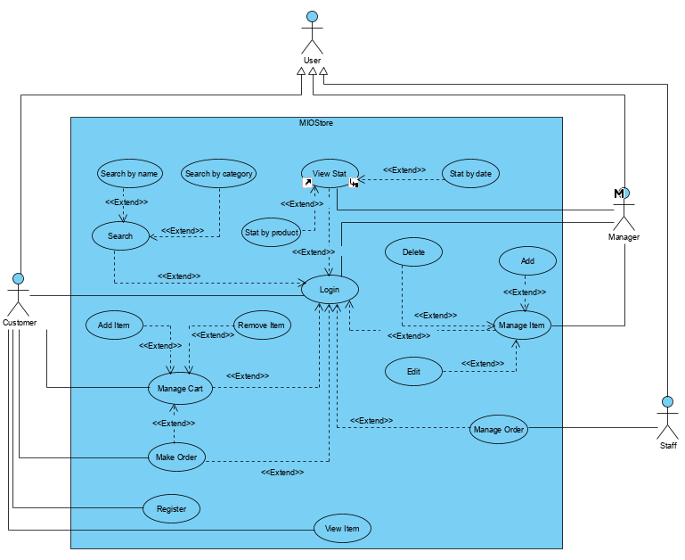***Biểu đồ use case***
2. ***User Stories***

|  |  |
| --- | --- |
| **User story** | **Acceptance criteria** |
| As a shopper I want to list of products so I can select some product to purchase | - See a thumbnail image for each product - Click to view detail product - Add to cart from detail page |
| As a shopper I want to search products | - Search by name, keyword,category - All of product show on web |
| As a shopper I want to review my orders so I can see what I have purchased in the past | - View a list of completed order  - See the status of order - Navigate to see detail of the order |
| As a shopper I want to review my cart | - View quantities and items in the cart - Remove items  - Adjust quantities of items - See a total cost before tax and shipping |
| As a shopper I want to checkout so I can get product shipped to me | - Enter shipping address - Enter bulling address - Enter a credit card number - Show total including tax and shipping  - Show confirmation message  - Verify payment |
| As a shopper I want to cancel my order | - See my order - Click to view detail - If my order is not processed, successful cancelation |
| As a manager I want to see all of the order and status of order | - View a list of order ordered by time - Add a label for each order - Choose shipper company  - Change status order from not proccessed to processing |
| As a manager I want to modify the list of products | - Add name for products - Add image for products - Add description for products - Add category for products |
| As a manager I want to add or delete product from web | - Delete products - Change the image for the product - Change cost of product - Change category of product |
| As a shipper I want to see all of the order and status of order | - View a list of order - Confirm order - Navigate to status order |
| As Customer, I want to search items by name on the webpage so that I can find necessary items. | - Enter item name and click search on search bar.  - View list result. |
| As Customer, I want to access the Item Detail Page so that I can see more information of item. | - Click image of an item to access Item Detail Page  - View information of item. |
| As Customer, I want Add To Cart feature in Item Detail Page so that I can add item to my shopping cart. | - View Cart icon on Item Detail page.  - Click Cart icon on Item Detail page to add item to shopping cart. |
| As Customer, I want to submit feedback so that the website owners can know my opinions. | - View feedback form on item detail page.  - Enter form and submit. |
| As Customer, I want to view my order detail so that I can know processing status of my order. | - View menu function of customer.  - Click View My Order menu to see order. |
| As Staff, I want to search order by date so that I can find order to process. | - Search order bar on View Order page with Date picker.  - Choose date and search.  - View list result. |
| As Staff, I want send message to customer account so that I can answer their questions. | - View messages of customer.  - Enter answer and click send back to customer. |
| As Manager, I want Edit Item feature so that I can make change on item information. | - Search Item.  - View list result.  - Choose an item to show information.  - Change information of item. |
| As Manager, I want to see statistics of bills so that I can evaluate revenue. | - Access the View Stats Page.  - Choose view stats by bills and enter form.  - See statitics |
| As Manager, I want to see statistics of order so that I can know customer trends. | - Access the View Stats Page.  - Choose view stats by order and enter form.  - See graph to get information about trending. |
| As a manage I want to view orders has been processed so that manage orders | * View order detail * Delete an order |
| As a manage I want to find the order by ID so that follow | * Enter ID you want to find orders * Click button search |
| As a manage I want to find the order by ID so that follow | * Enter the date you want to find orders * Click button search |
| As a order processing staff I want to view new orders so that process | * Click button Process order * View new orders * Click an order line |
| As a order processing staff I want view invoice so that comfirm payment for customer | * Click button Invoice * View information Invoice * Button comfirm |
| As a order processing staff I want check accept order so that process next order processing steps | * Comfirm with customer * Click button accepted order |
| As a order processing staff I want comfirm shipping so that delivery | * Click button shipping * Enter information ship * Click button shipping * Click button comfirm |
| As a manage I want see order details so that follow order status | * View information order details: customer information, picked item, shipping, order status..... |
| As a manage I want see order details so that order managemet | * View information order details: customer information, picked item, shipping, order status..... |
| As a manege I want view list product so that product management | * Add item * Delete item |
| As a manager I want to see stat by product so I can see number of product sold | * See table result in result Frm * Search for product * See product info in table |
| As a manager I want to see stat by staff so I can see number of product sold by a staff | * See table result in result Frm * Search for staff in table order in database * See staff information in table |
| As a manager I want to see stat by product in managerFrm so I can see stat by product in a period | * Click in view stat by product in mainFrm to view * Enter startDate and endate * Search for product in table bill in database |
| As a manager I want to see stat by staff in managerFrm so I can see stat by staff in a period | * Click in view stat by staff in mainFrm to view * Enter startDate and endate * Search for staff in table bill in database |
| As a manager I want to see stat by type of product in managerFrm so I can see stat by type product in a period | * Click in view stat by type product in mainFrm to view * Enter startDate and endate * Search for type product in table bill in database |
| As a manager I want to see stat in a period of time in managerFrm so I can see stat in a period | * Click in view stat by time in mainFrm to view * Enter startDate and endate * Search for time in table bill in database |
| As a manager I want to see product’information in statFrm so I can distinguish products | * Show product info in table result * Search for product in table productInfo in database * Click in a line to see full information of this product |
| As a manager I want to see staff’information in specificallyStatFrm so I can see who sell this products | * Show staff’name in table result * Click to view full staff’information |
| As a manager I want to see date time in specificallyStatFrm so I can see the when the products sold | * Show date time in table result * Click to view full bill’information |
| As a manager I want to see product’information in specificallyStatFrm so I can know products’information | * Show product’id in table result * Click to view full product’information |
| As a manager I want to manage my items so I can add a new item | - Fill the name, type, price … of Item - Insert the image of item |
| As a manager I want to manage my items so I can delete an item | - Search by name, keyword,category |
| As a manager I want to manage my items so I can update an item | - Search by name, keyword, category  - Change the name, type, price … of Item - See detail of Item |
| As a shopper I want to review my cart so that I can adjustments prior to checkout | - View quantities and items in the cart - Remove items  - Adjust quantities of items - See a total cost before tax and shipping |
| As a shopper I want to view a list products so I can select some to purchase | - Search by name, keyword,category - Show detail of Item - Add Item to cart |
| As a shopper I want to cancel my order | - See my order - Click to view detail - If my order is not processed, successful cancelation |
| As a manager I want to see all of the order and status of order | - View a list of order ordered by time - Add a label for each order - Choose shipper company  - Change status order from not proccessed to processing |
| As a manager I want to modify the list of products | - Add name for products - Add image for products - Add description for products - Add category for products |
| As a manager I want to add or delete product from web | - Delete products - Change the image for the product - Change cost of product - Change category of product |
| As a shipper I want to see all of the order and status of order | - View a list of order - Confirm order - Navigate to status order |

***5. CRC Card***

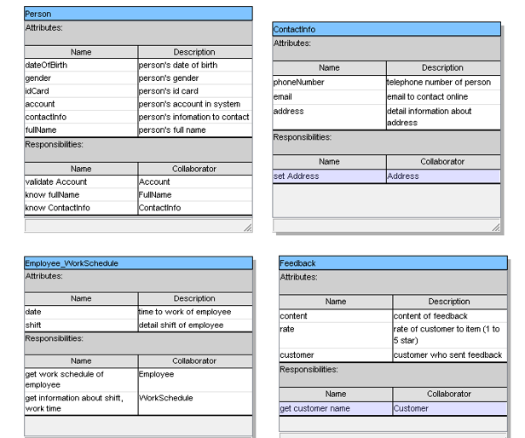

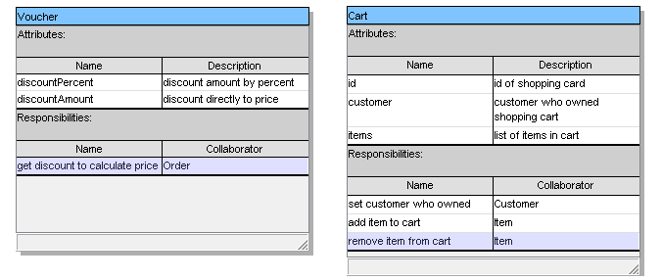

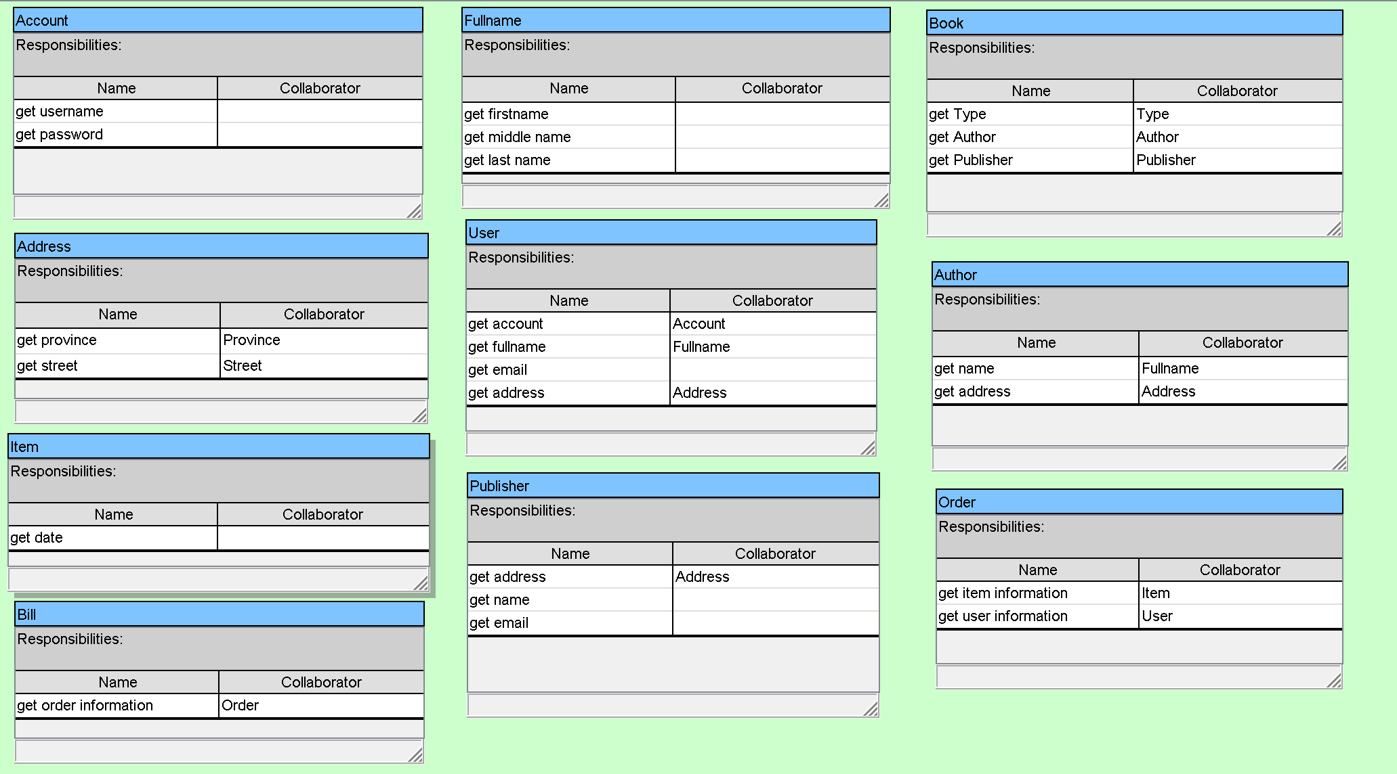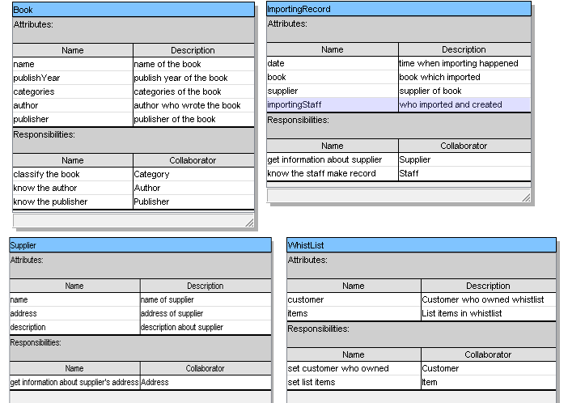

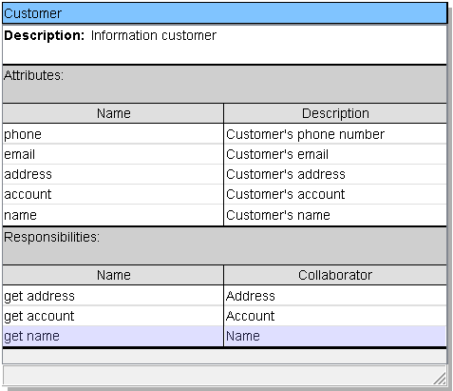

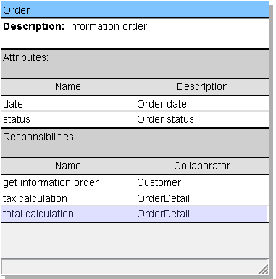

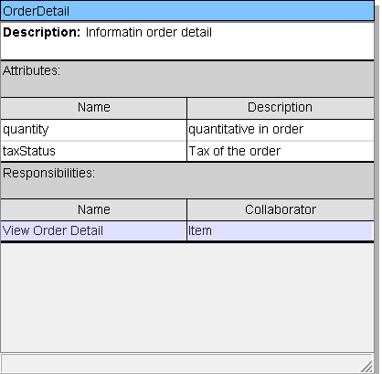

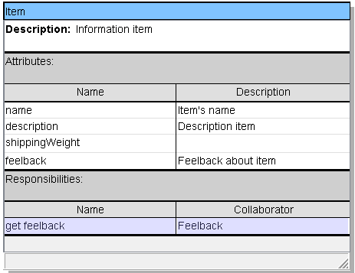

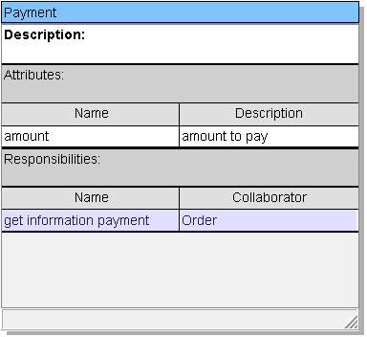

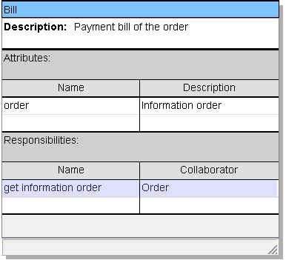

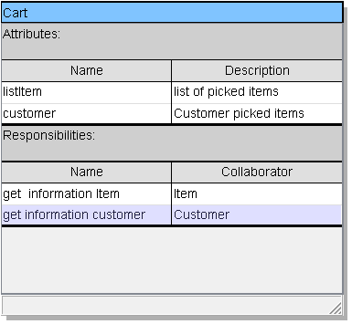

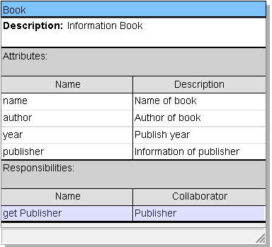

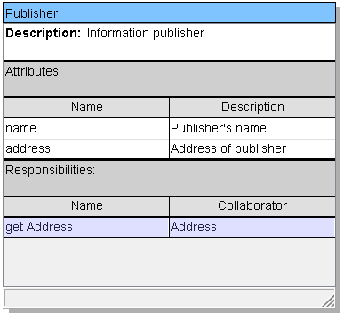

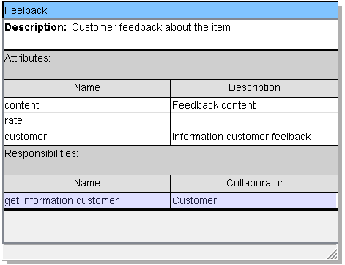

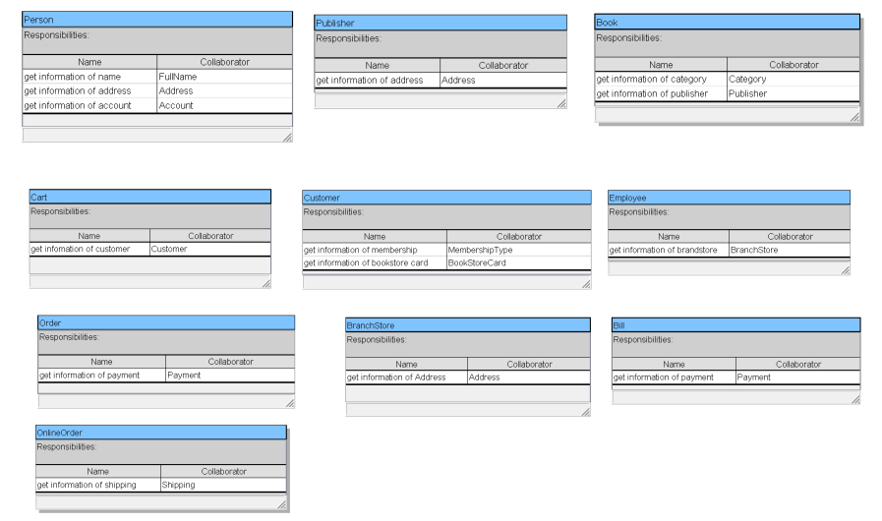

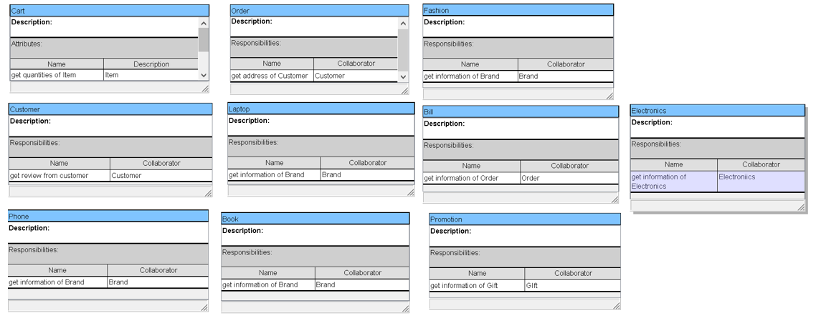

**Chương 2: Cơ sở 4 + 1 view cho Thiết kế kiến trúc**

**2.1 Logical View**

**2.1.1 Class Diagram**

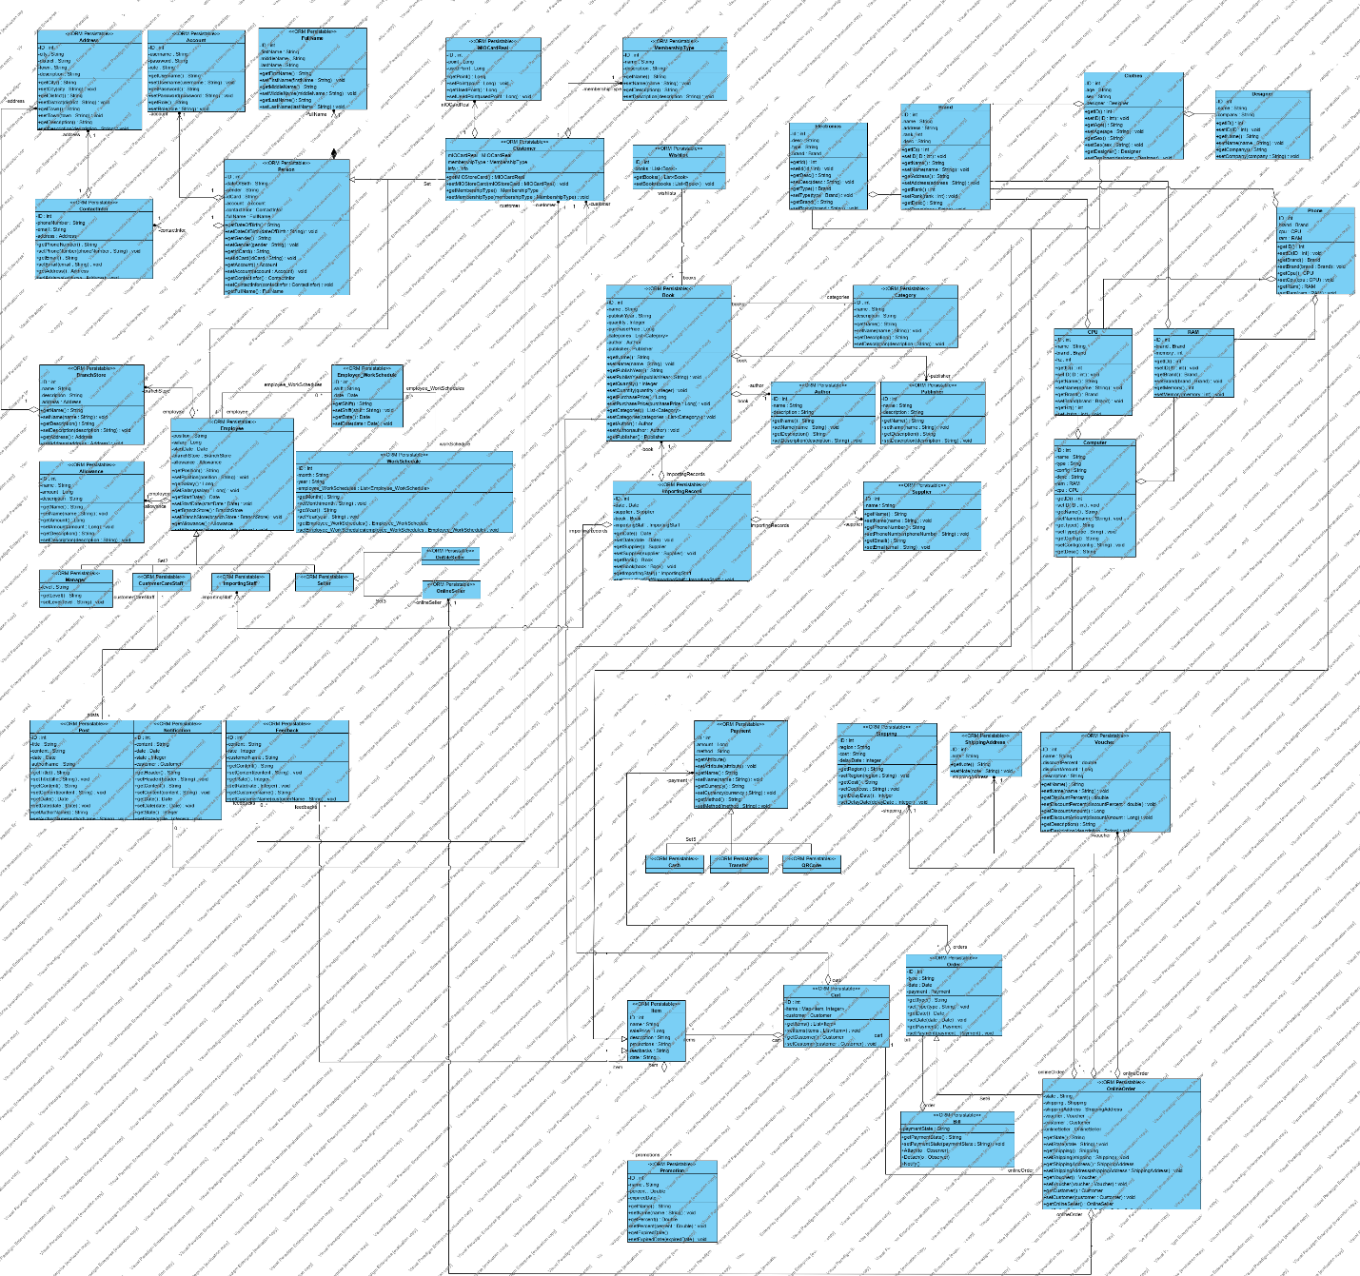

**2.1.2 State diagram**

**Sign Up**

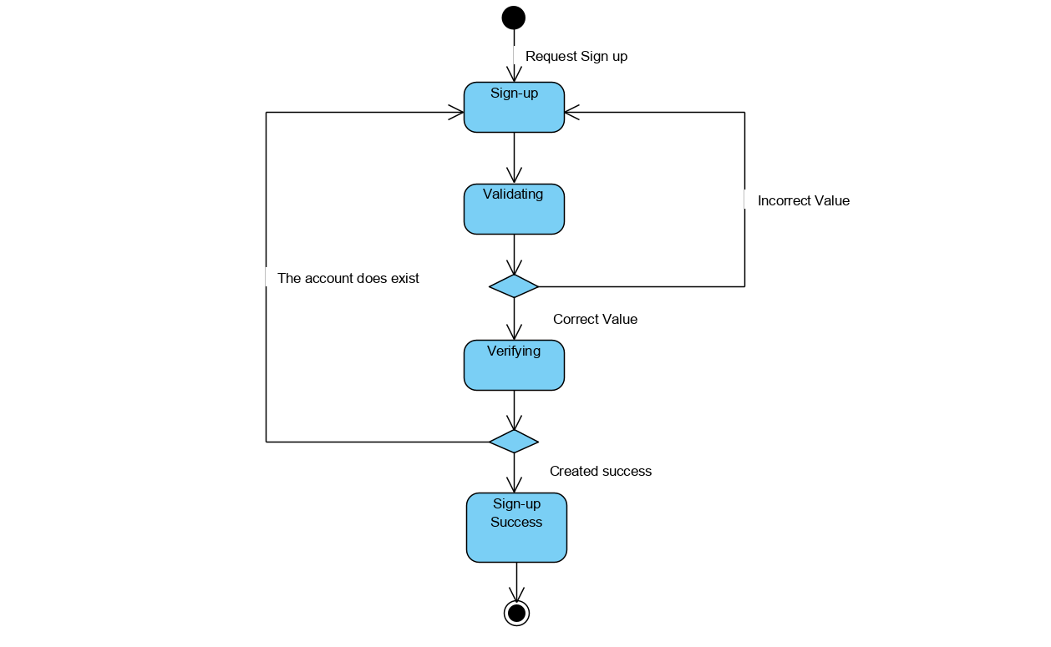

**Manage Item**

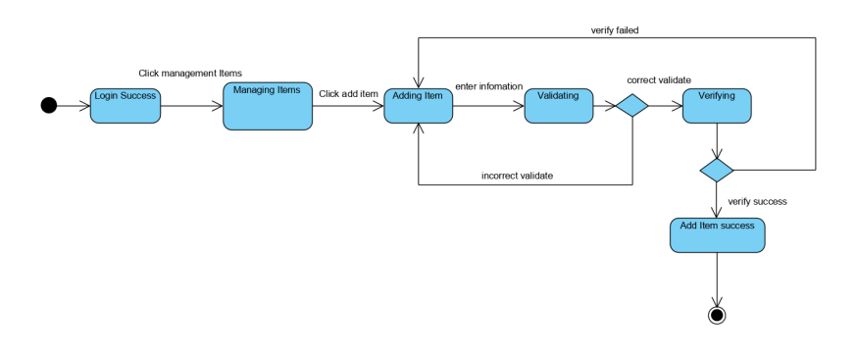

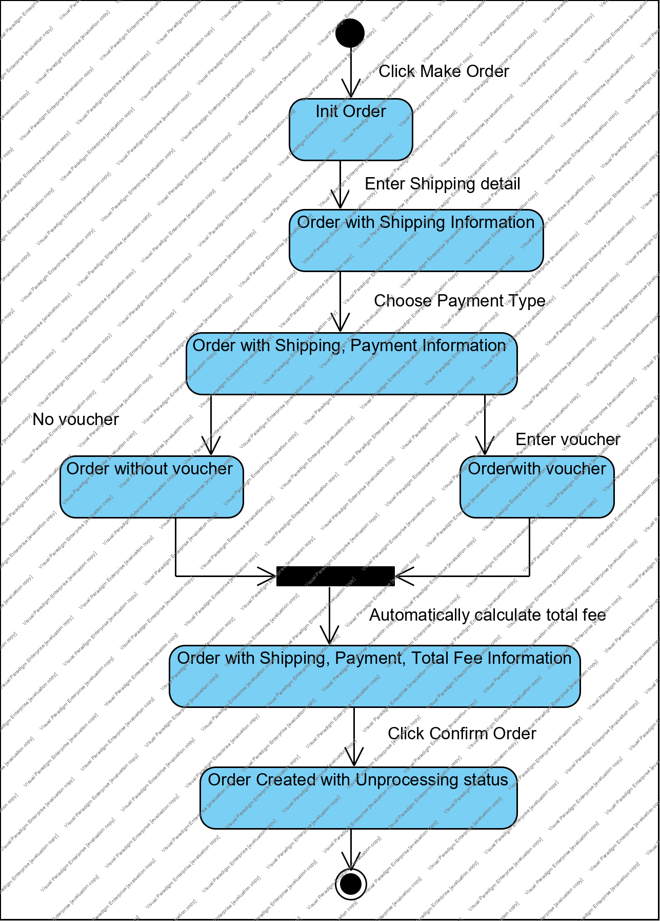**Make Order**

**Manage Order**

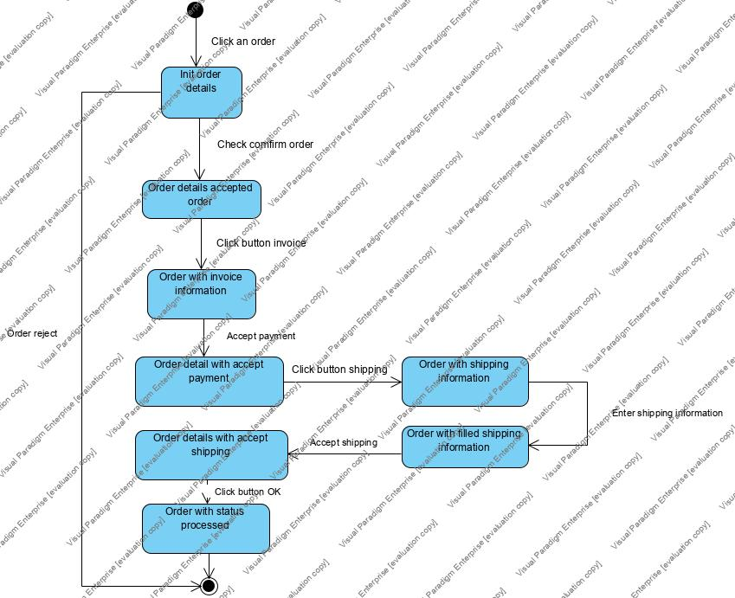

**View Stat**

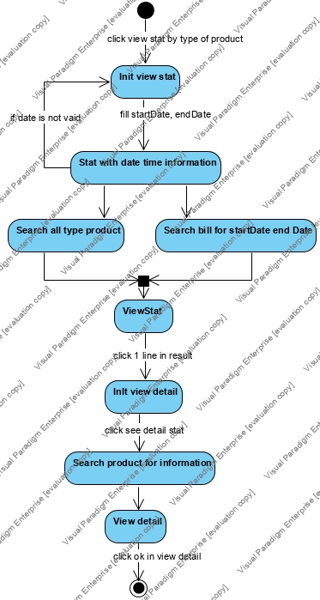

**2.2 Process View**

**2.2.1 Activity Diagram**

**Sign Up**

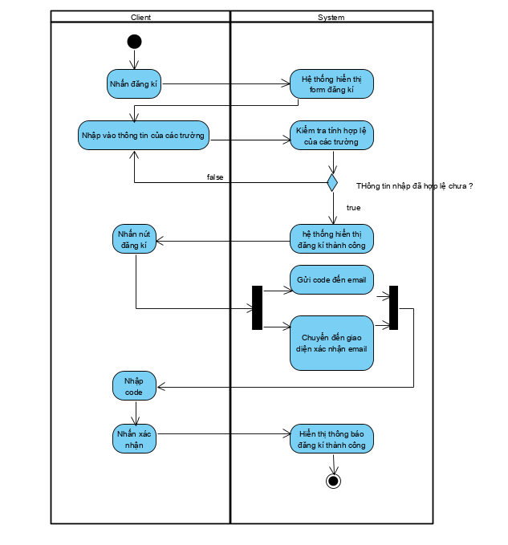

**Sign In**

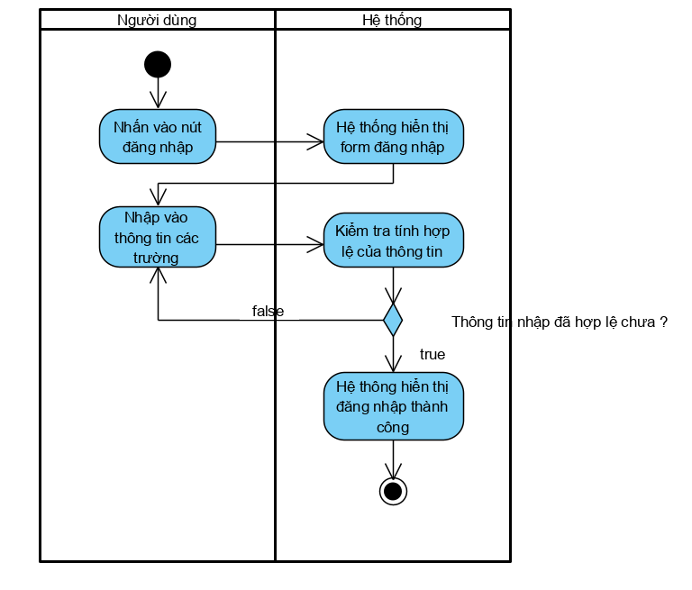

**Manage Item**

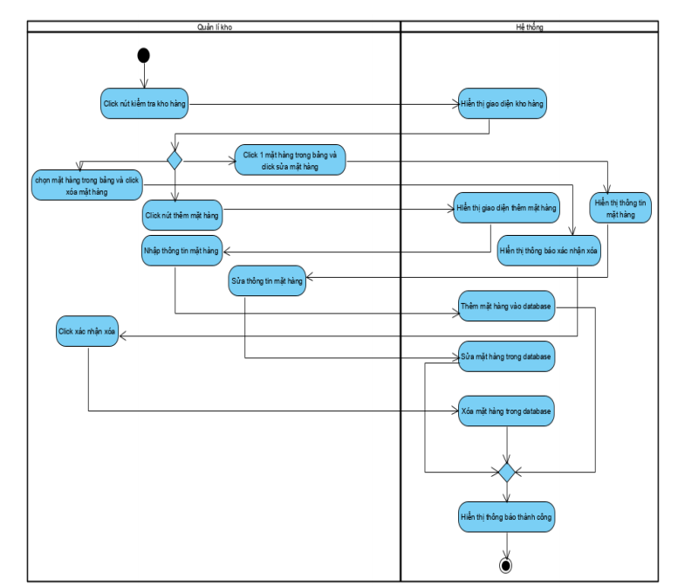

**Make Order**

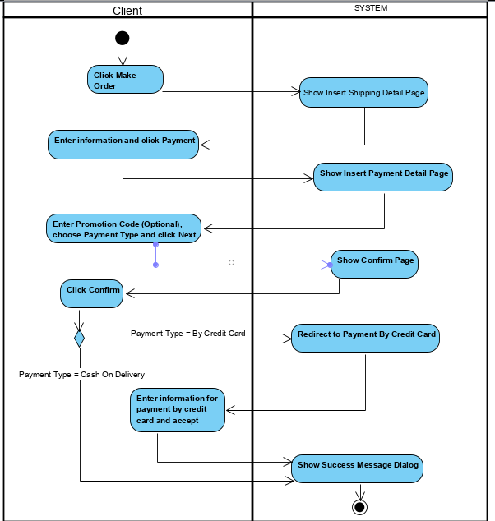

**Manage Order**

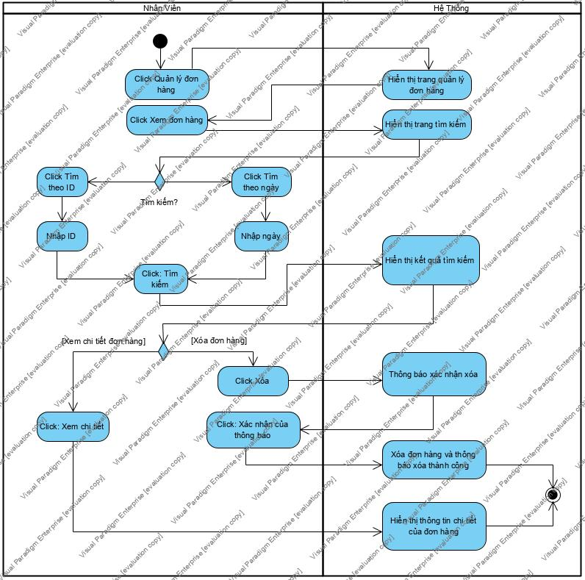

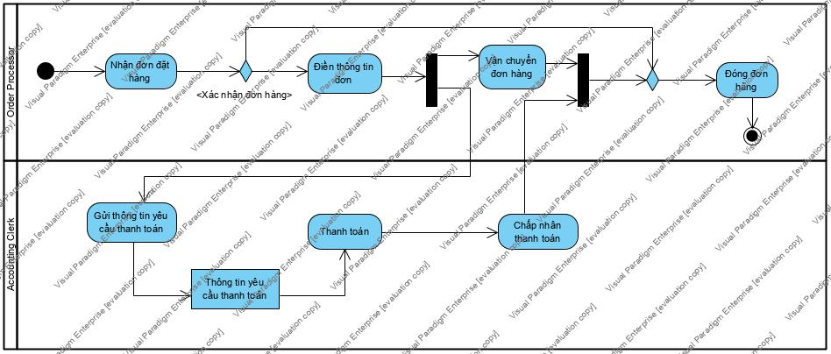

**View Stat**

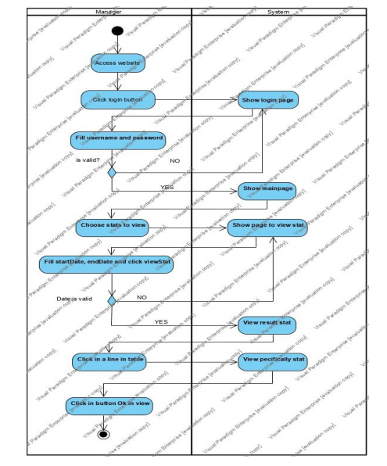

**2.2.2 Sequence Diagram**

**Sign Up**

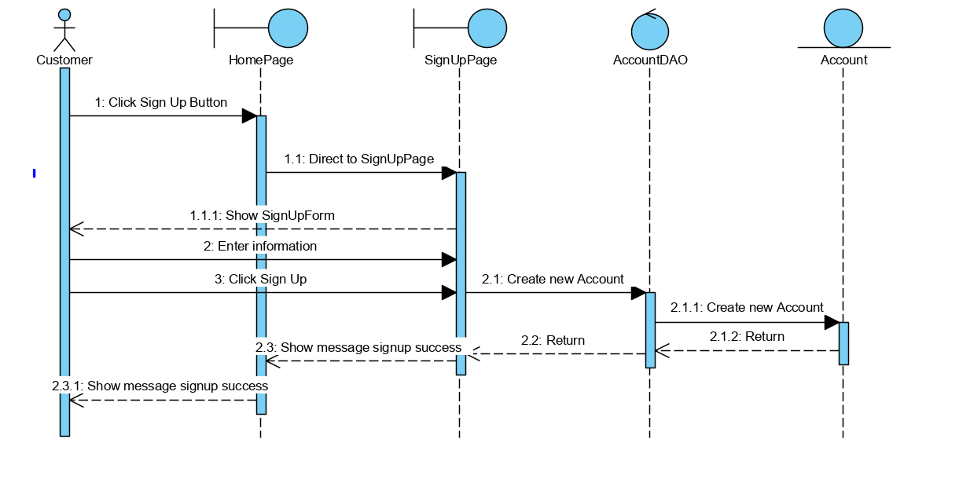

**Manage Item**

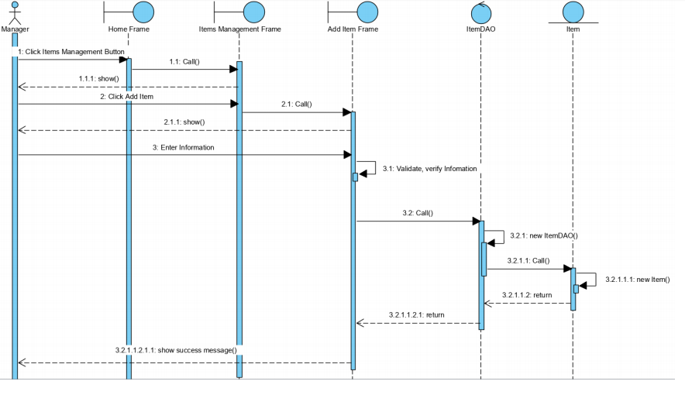

**Make Order**

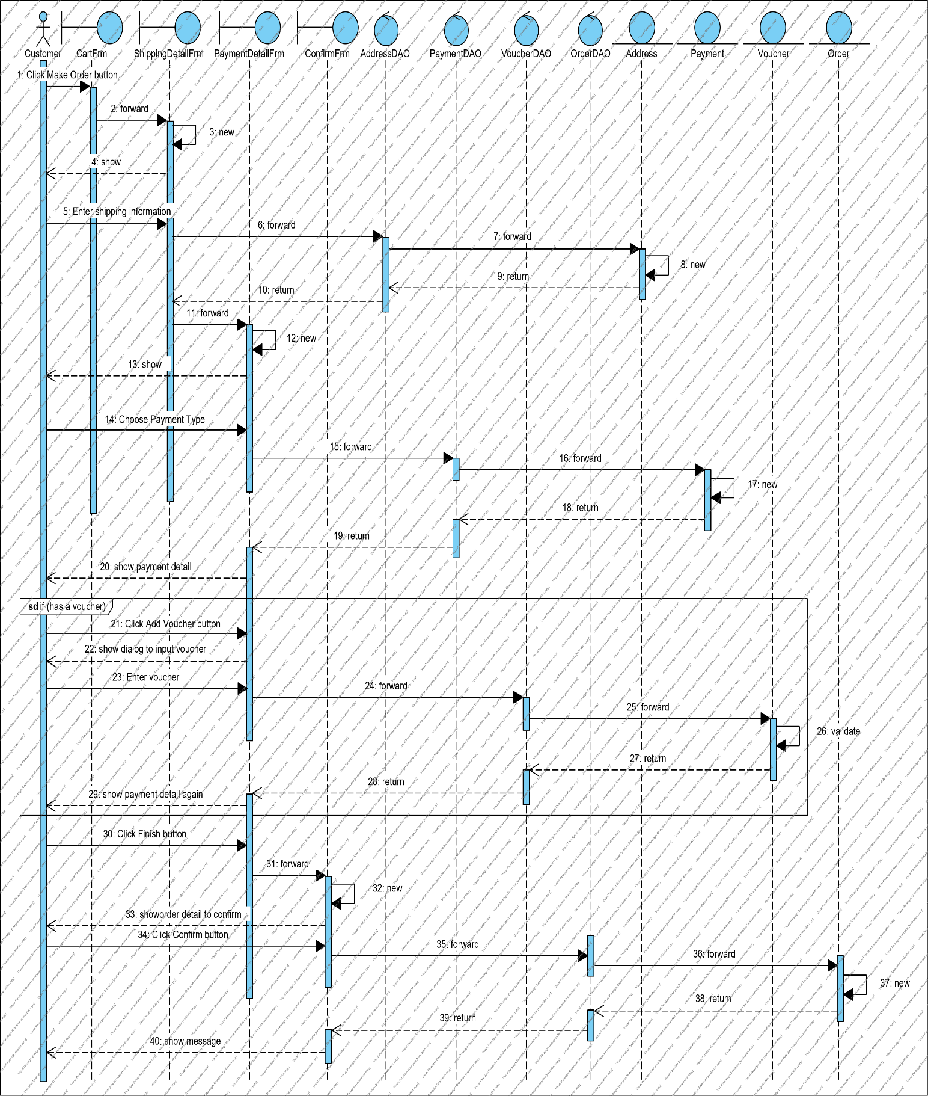

**Manage Order**

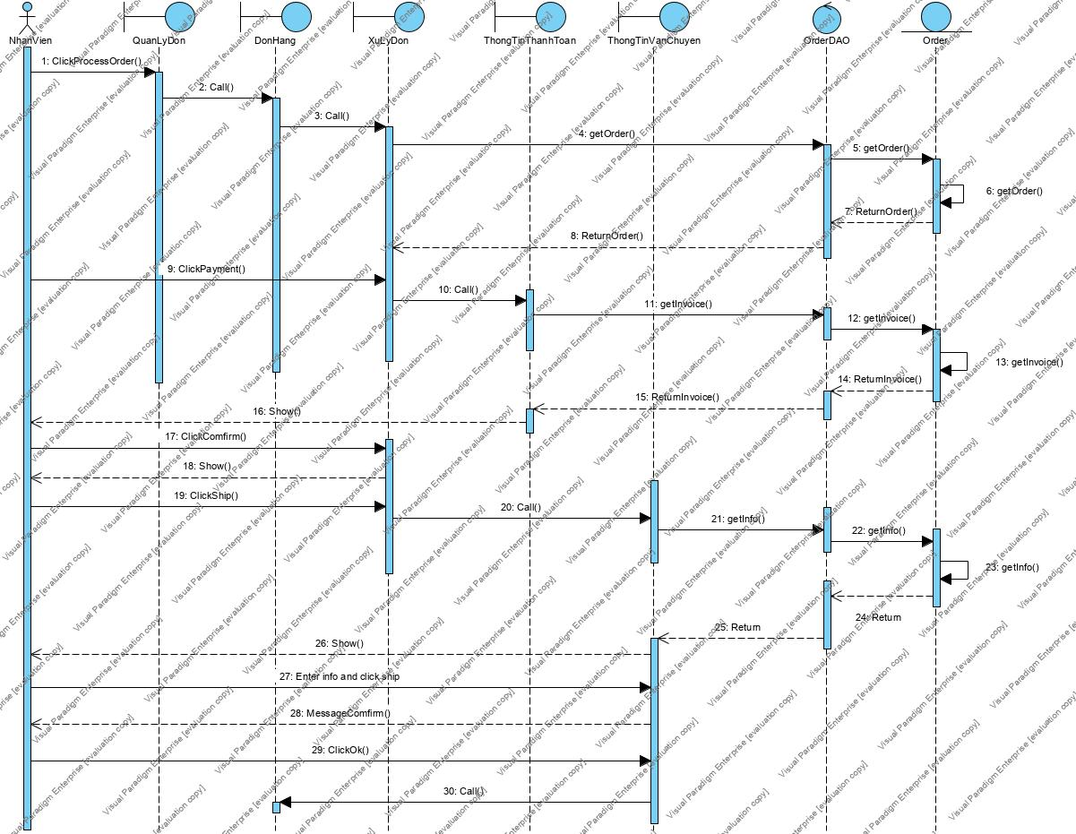

**View Stat**

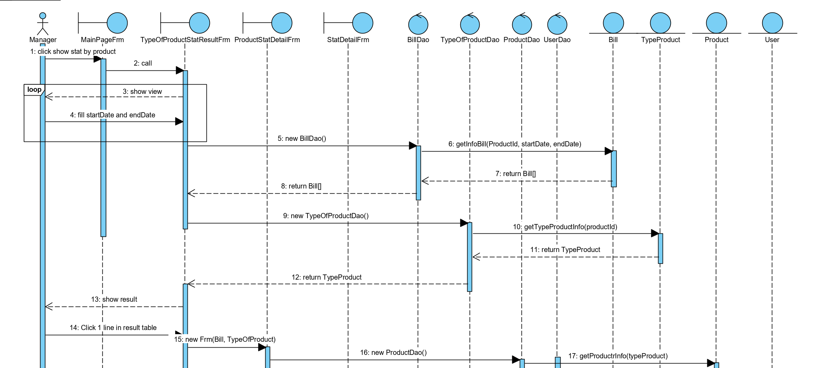

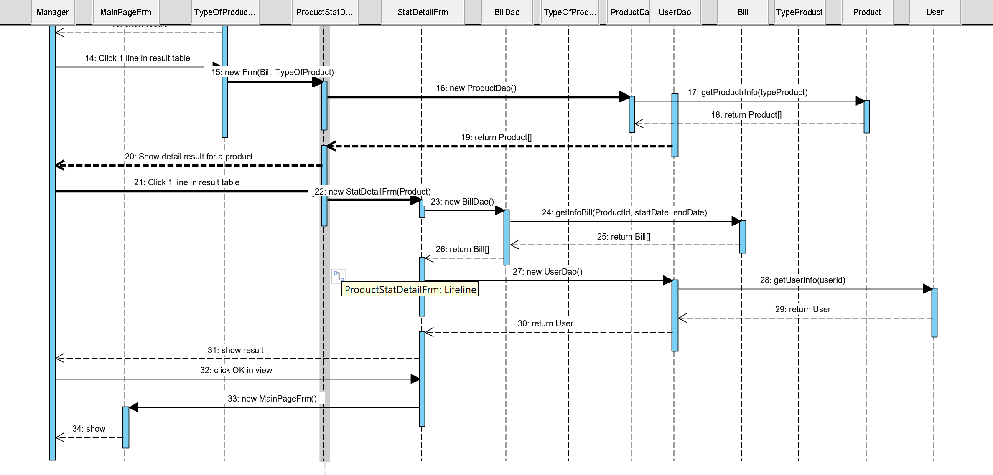

**2.3 Deployment View**

**Component diagram**

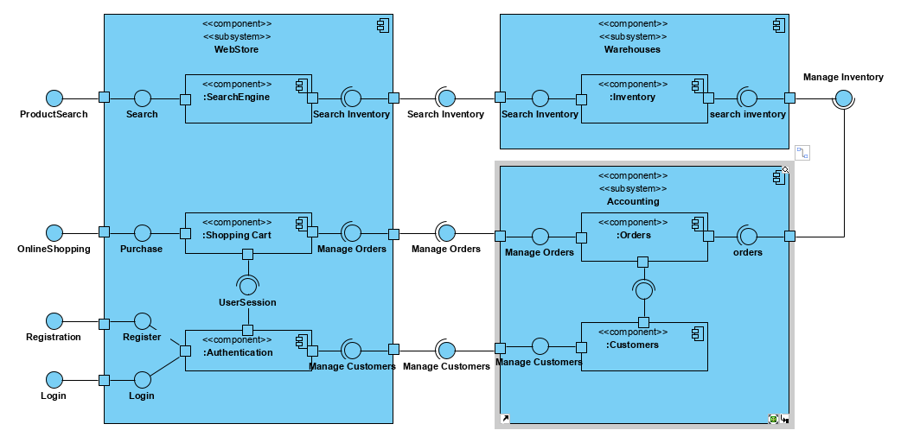

**Package diagram**

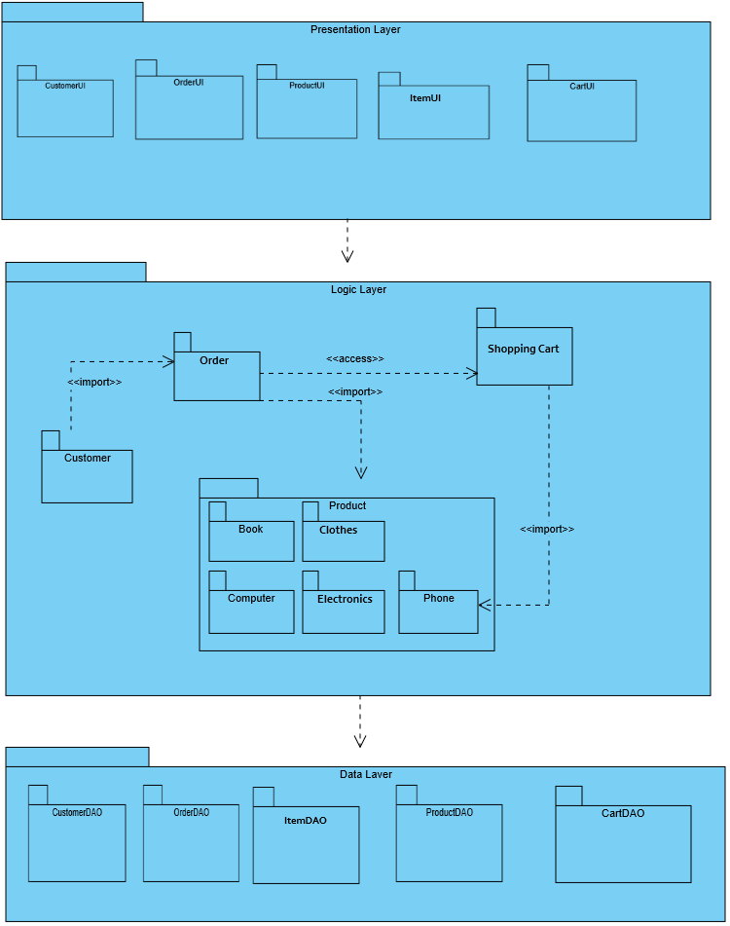

**2.4 Deployment View**

**Deployment Diagram**

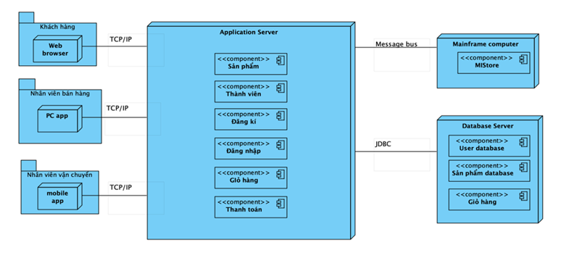

**Chương 3: Biểu đồ lớp chi tiết – Gói và mẫu thiết kế - Cơ sở dữ liệu**

**• Thiết kế package/subsystem/detail** 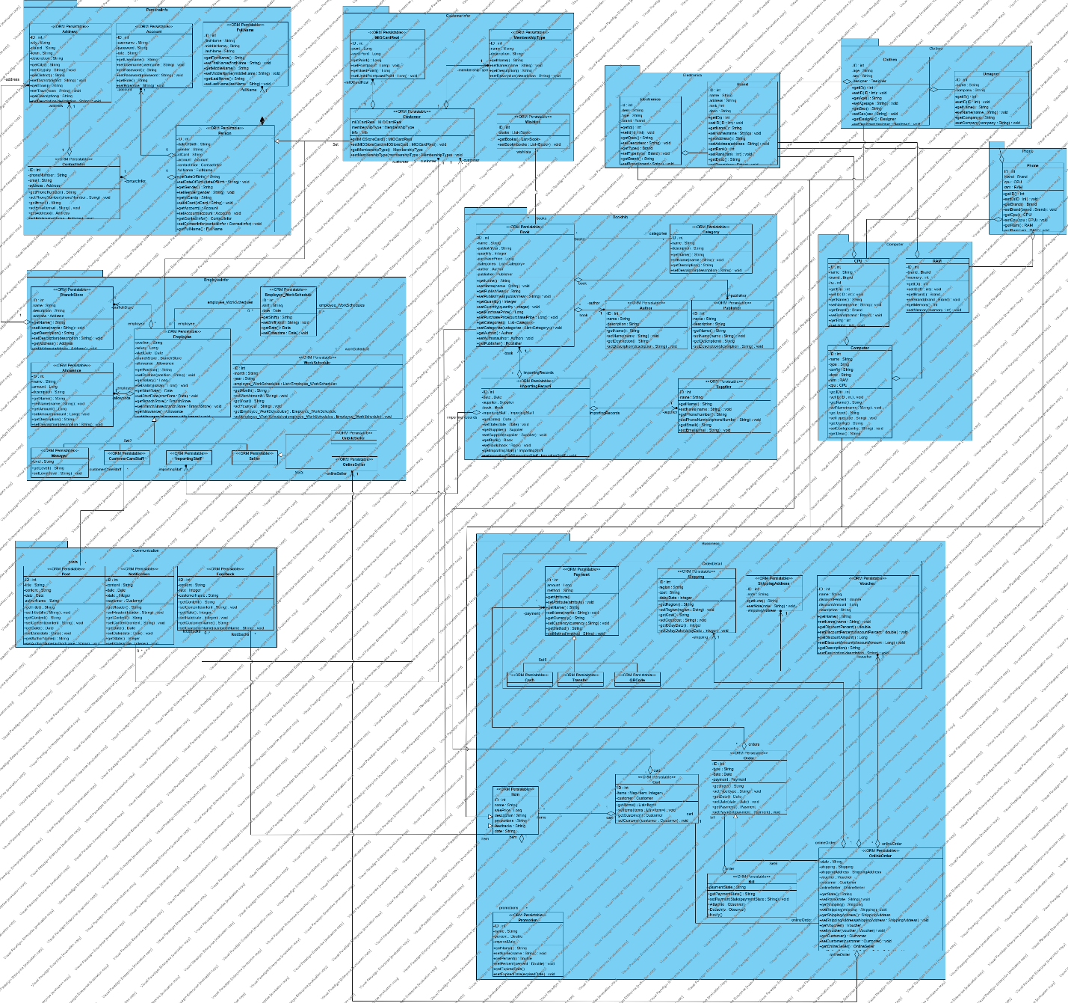

**• Áp dụng các mẫu thiết kế**

**Sign Up**

Các pattern sử dụng: Facade Pattern.

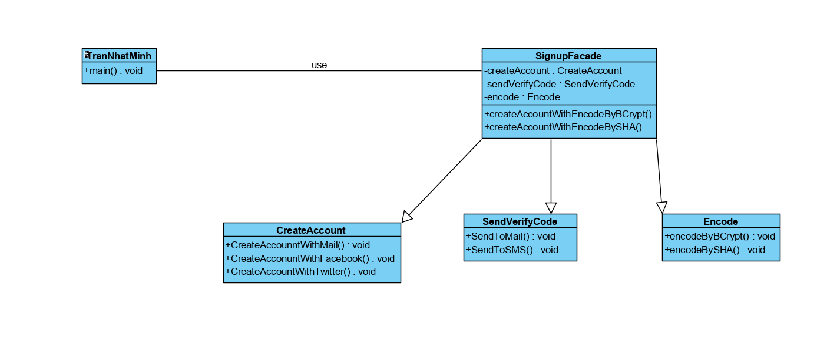

**Employee Info**

Các pattern sử dụng: Dao Pattern

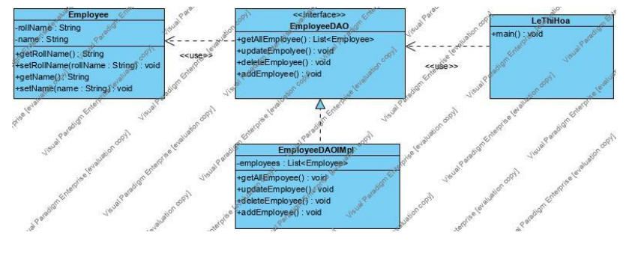

**Customer Info**

Các pattern sử dụng: facade, dao, flyweight và proxy

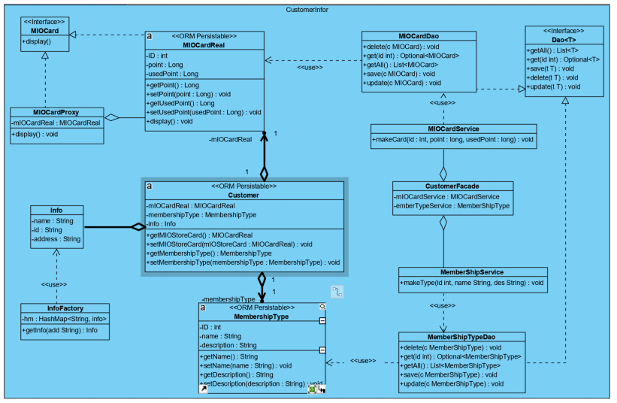

**Manage Item**

Các pattern sử dụng: Builder Pattern, Dao Pattern, Facade Pattern, Decorator Pattern, Composite Pattern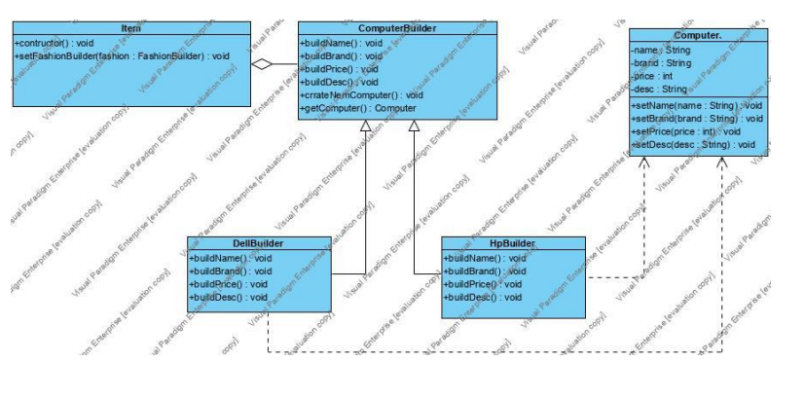

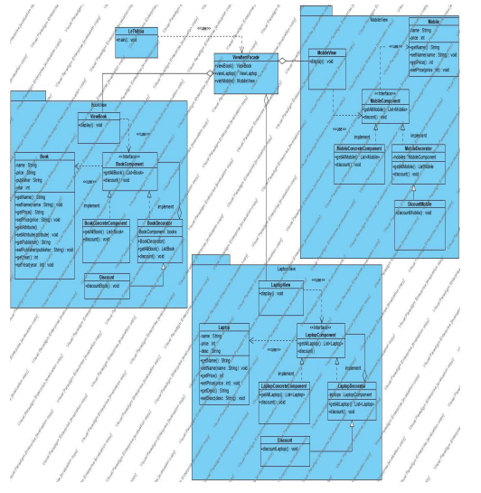

**Make Order**

Các pattern sử dụng: Adapter Pattern, Bridge Pattern, Dao Pattern, Facade Pattern.

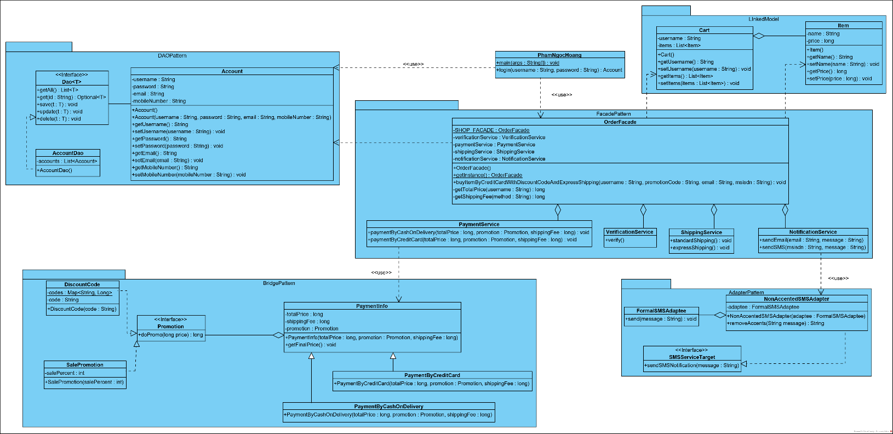

**• Thiết kế database**

